**Setup to run the api automation**

* Install eclipse
* Go to help -> Marketplace ->install TestNg
* 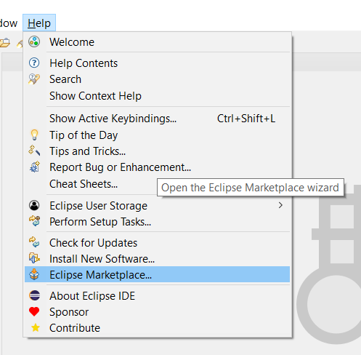
* 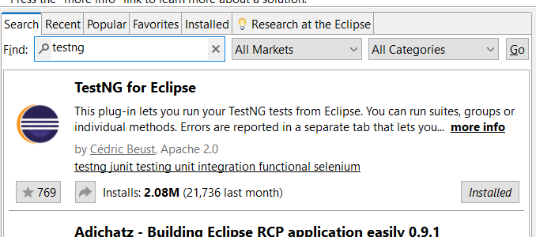
* Import the api -automation testing project
  + Go to file -> import.. -> existing Maven projects
  + Select the api automation testing project
* Once importing project is successfully completed you will get a project structure
* 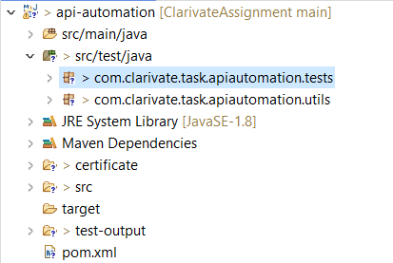
* Go to com.clarivate.task.apiautomation.tests and open RestCountriesAPITest.java file
* Right click on the opened file and run as testing
* Once test is executed successfully response from the API is validated in the code and printed in console.